CSC 4360 - In-Class Activity 14 Submission
Student: Trajuan Smith
GitHub Repository: https://github.com/Myriad21/Firebase_Cloud_Messeging_TrajuanSmith

Prompt 1: Setup Reasoning
FlutterFire configuration was the correct first step because Firebase Cloud Messaging depends on a valid connection between the Flutter app and the Firebase project. Without proper configuration, the app would not be able to initialize Firebase services or retrieve a valid FCM token, which is required for message delivery. By running the FlutterFire CLI and generating firebase_options.dart, the app was linked to the correct Firebase project and platform configuration. This reduced debugging complexity later, because any messaging errors could be isolated to logic rather than setup issues. The successful retrieval and display of the FCM token in the app confirms that the configuration was completed correctly.
Evidence
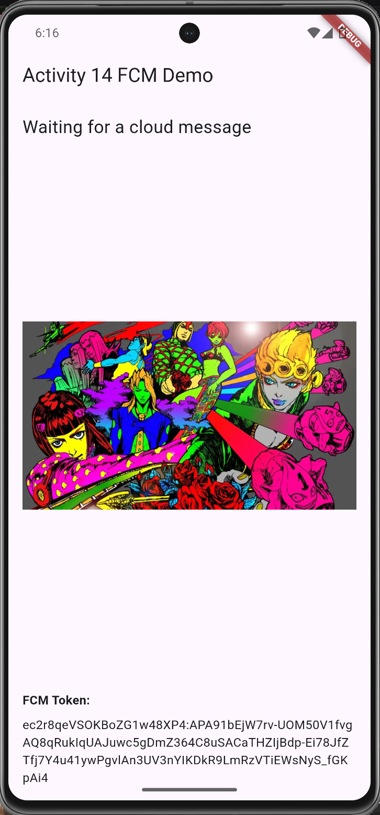
Figure 1: Successful Firebase initialization and FCM token retrieval

Prompt 2: Lifecycle Analysis
The app behaves differently depending on whether it is in the foreground, background, or terminated state, and each state uses a different Firebase Messaging handler. In the foreground state, the onMessage listener is triggered, and the UI updates immediately without requiring user interaction. In the background state, the notification is displayed in the system tray, and tapping it triggers onMessageOpenedApp, which reopens the app and processes the payload. In the terminated state, the app is fully closed, and tapping the notification launches the app and processes the message using getInitialMessage(). These differences were verified through testing, where each state produced the expected UI updates and logs corresponding to the correct handler.
Evidence:
Figure 2: Foreground message handling (onMessage): https://drive.google.com/file/d/1PDdQRajcIyeubFLfzn6EQNO8uOT8uvxX/view?usp=sharing
Figure 3: Background notification tap handling (onMessageOpenedApp): https://drive.google.com/file/d/1bbetLUpZ5L31cFYtqvOkt747syqQ5nw3/view?usp=sharing
Figure 4: Terminated-state launch handling (getInitialMessage): https://drive.google.com/file/d/1gzohLQBcCbYcups0HQHEc6-wlJDJlSNE/view?usp=sharing

Prompt 3: Debug Evidence
One bug encountered during development was that the image failed to load when the app was launched from a terminated state. The UI displayed an “Image could not be loaded” message, indicating that the asset path was incorrect or not resolved properly. To diagnose the issue, debug logging was added to print the payload data and the resolved asset path. This revealed that the app was attempting to load an asset with a mismatched extension or incorrect path. The issue was resolved by ensuring that the asset filenames matched the expected .webp format and performing a full rebuild using flutter clean and flutter run. The fix was validated when the app successfully loaded the correct image after being launched from a terminated state.

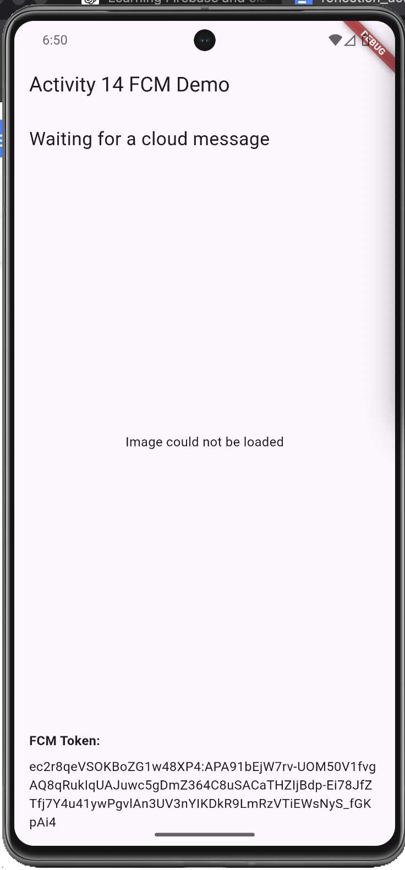
Evidence

Fix:
Figure 5: Debugging and resolution of asset loading issue in terminated state: https://drive.google.com/file/d/1gzohLQBcCbYcups0HQHEc6-wlJDJlSNE/view?usp=sharing

Prompt 4: Payload Design
The payload was designed using both notification and data fields to support UI updates and testing flexibility. The notification section included a title and body to display a visible message to the user, while the data section included custom keys such as asset and action. The asset key was used to dynamically determine which image to display in the UI, allowing the app to react to cloud-delivered content. This design was appropriate because it separates user-visible messaging from application logic, enabling flexible UI updates without modifying the app code. The effectiveness of this design was confirmed through testing, where changing the asset value in the payload resulted in different images being displayed.
The main trade-off in this implementation was choosing to start with simple UI updates, such as changing text and images, instead of implementing more complex features like animations or advanced notification customization. This decision simplified debugging and made it easier to verify that the data payload was being received and processed correctly. While this limited the visual complexity of the app, it reduced the risk of introducing additional bugs and ensured that the core messaging functionality worked reliably before adding enhancements.
Evidence
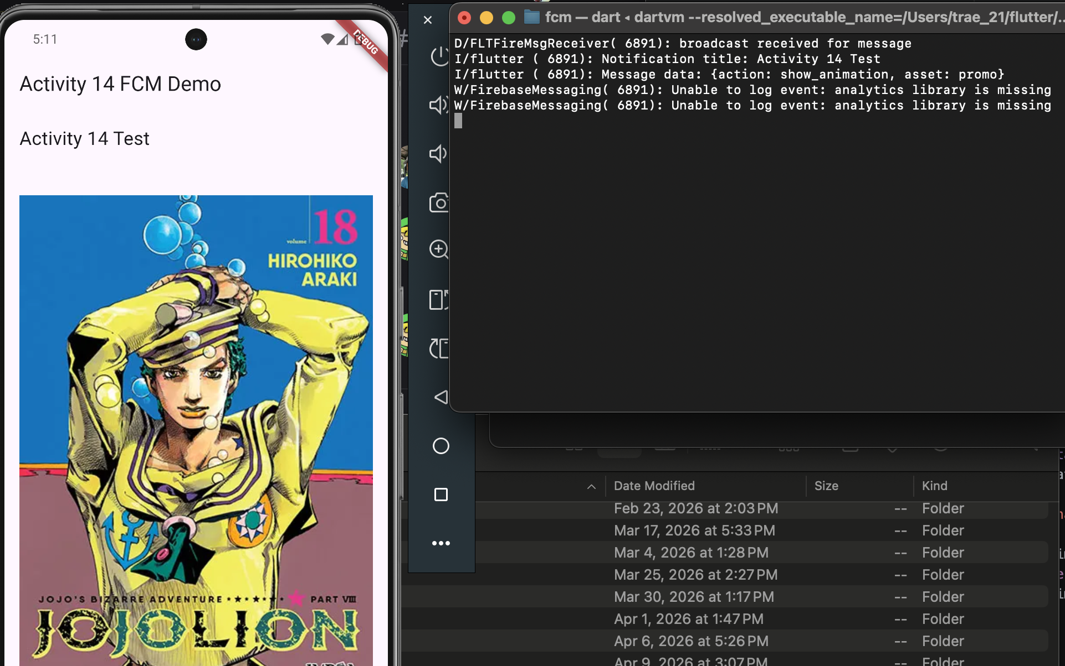
Figure 6: Payload-driven UI update using custom data fields
Also relevant is the foreground video: https://drive.google.com/file/d/1PDdQRajcIyeubFLfzn6EQNO8uOT8uvxX/view?usp=sharing

Prompt 5: Improvement Plan
If given additional time, the next improvement would be implementing richer notification handling and user experience enhancements. For example, the app could use the flutter_local_notifications package to display customized notifications while the app is in the foreground, ensuring consistent behavior across all states. Another improvement would be adding animations or transitions when the UI updates in response to payload data, making the app feel more dynamic. Additionally, logging and error handling could be expanded to provide clearer feedback when payload data is missing or malformed. These improvements would enhance both usability and robustness while maintaining the existing architecture.

